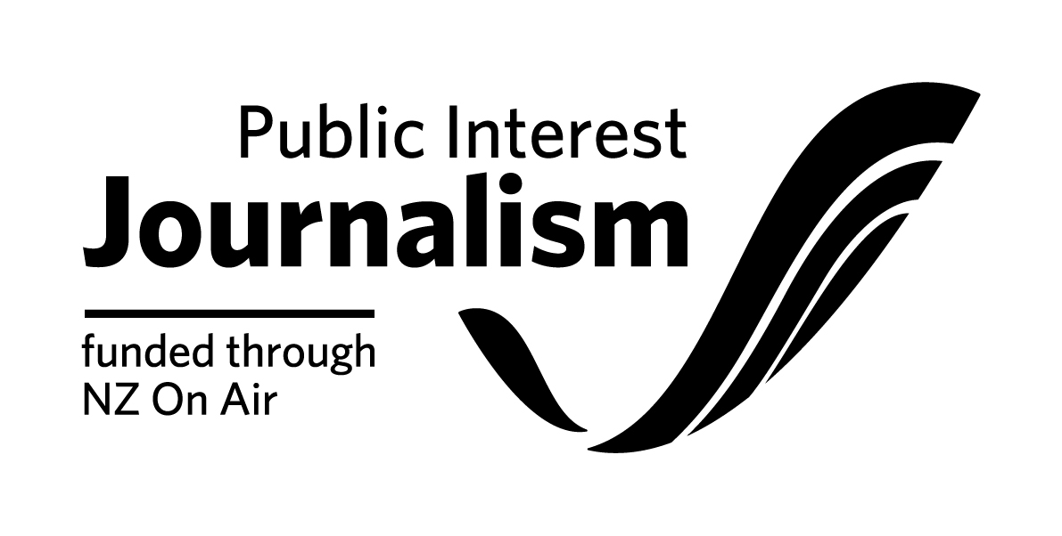

Roles Funding Contract Initiation Form

Please note: NZ On Air will begin drafting your funding contract once we receive both this
form, platform confirmations of your rights and completed necessary attachments from you. We aim to have a draft contract back to you within 20 working days of receiving your initiation, provided all the information from you is complete and correct.

Full Legal Name of your Company:

Location of Company’s Registered Office (City Only):

Necessary Attachments to go with the below form:
□ Employment agreement (This must include all clauses outlined in Schedule 8 of our Roles Funding Agreement template and Appendix B of your letter of offer)
□ Roles Budget
□ If applicable, a completed reporting requirements spreadsheet, found here
Producer Contact Details
Main contact person
Email address
Physical Address | (Please ensure you put correct postal code for both addresses)
Postal Address
Phone (landline & mobile)
Bank Account number:

Role Details
Role title
Role Type | Employee/Contractor (delete one)
Name | (of the person filling the role)
Salary
Term of Employment

If your role is content producing:
Primary platform | (name of the platform)
Estimated reach | (for example previous programme ratings, website reach, circulation)
Type of content | e.g. stand alone website, articles, audio features, magazine content
Number of Stories (please state time period e.g. per week, per month)
Duration/word count (either per story or total)
Expected story dates (if applicable)

Budget & Funding Details
Budgeted Costs | Budgeted Cash Costs
 | Budgeted Non-Cash Costs
 | Total Budgeted Costs
Funding | NZ On Air Funding
 | Producer/Primary Platform Funding
 | Additional Funding
 | Total Funding

Insurance:
Do you have, or are you planning to get, any insurance specifically for the production of this funded content?
□ No (Please note that the funding agreement will require you to have Insurance cover as is prudent. It is not necessary to have project-specific insurance but we do expect you to at least have various blanket insurance agreements which will cover some risks)
□ Yes (Please write list of insurance types you have or are planning to get below)

