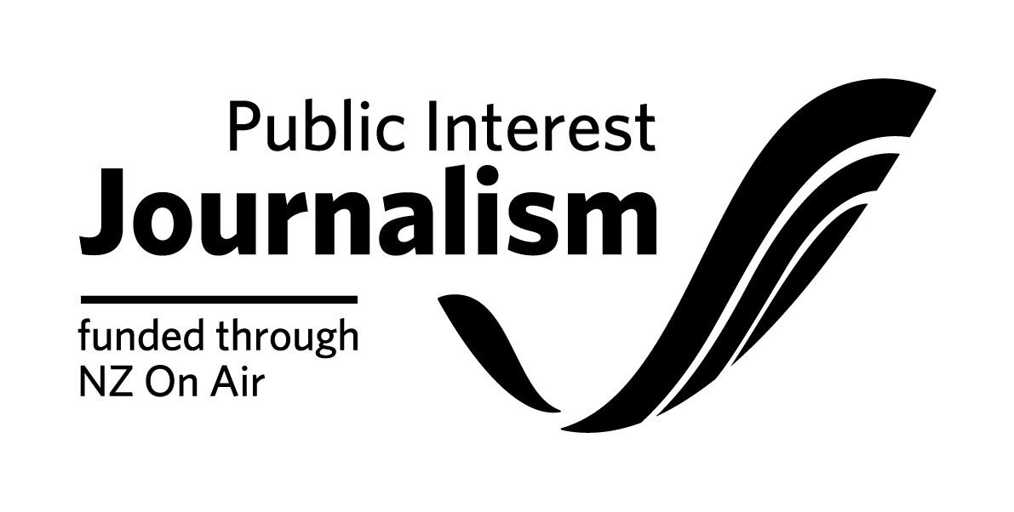

Project Funding Contract Initiation Form

Please note: NZ On Air will begin drafting your funding contract once we receive both this
form, platform confirmations of your rights and completed necessary attachments from you. We aim to have a draft contract back to you within 2 working weeks of receiving your initiation, provided all the information from you is complete and correct.

Full Legal Name of your Company:

Location of Company’s Registered Office (City Only):

Necessary attachments to go with the below form:
□ Project Budget
Important: Please specify/highlight items in your budget that will/may be internal or Related Party Cost items.
By Related Party Costs we mean any payment to the Applicant; any shareholder, director, or employee of the Applicant; any near relative of a shareholder or director of the Applicant; and any entity in which any director, shareholder or near relative has a financial interest, or any payment for the producers internal costs, such an edit suite, camera’s etc. The Producer is not to increase the rate for Related Party Costs highlighted in the Project Budget without the written consent of NZ On Air. The Project Budget is to be approved by NZ On Air before issuing the contract for signing.
□ Drawdown Schedule.
NZ On Air has default drawdowns for different types of projects. These are set out in our Drawdown section on our website. We prefer to round the drawdown amounts.
If this default position is not suitable for your project, please provide a preferred drawdown schedule. Note that your drawdowns should be tied to production events (e.g., offline approval) rather than dates. 5% should be reserved for payment on delivery to the Platform and 5% for delivery of final reports and a USB/DVD copy to us. Please note that no funds will be released until satisfactory documentation has been completed.

□ Project Schedule (Please specify applicable research, preproduction, shoot, offline, delivery, release dates).

□ If applicable, a full schedule of Non-Cash items to be used for this production. Including, but not limited to, any Platform facilities provided as part of the platform funding.

□ Net Income Shares (where NZOA funding is $200,000 or over): Our standard terms for net income shares are 75% in favor of the Recipient, unless the project involves significant Recipient or third-party equity investment.

Recipient Contact Details
Main contact person
Email address
Physical Address | (Please ensure you put correct postal code for both addresses)
Postal Address
Phone (landline & mobile)
Project Bank Account number:

[PLEASE DELETE THAT WHICH IS NOT APPLICABLE TO YOUR FUNDED PROJECT]

If your project is content producing:
Primary platform | (name of the platform)
Estimated reach | (for example previous programme ratings, website reach, circulation)
Type of content | e.g. stand alone website, articles, audio features, magazine content
Number of Episodes/Stories (please state time period e.g. per week, per month)
Duration/word count (either per story or total)
Expected story dates (if applicable)

Other Content Details (any content to be distributed via Additional Platform/s or Social Media)
Type of content | e.g. stand alone website, articles, audio features, magazine content
Platform/s for other content | e.g. name of channel, newspaper, website, social media site, radio station
Number of Episodes | If Applicable
Duration of Episodes | If Applicable e.g. 44’00” being 1 commercial hour
Total Duration
Release Date/s | First Episode/Article/Feature:  Last Episode/Article/Feature:
Other details | e.g. minimum number of non-AV articles etc to be produced as part of the budget

Key Personnel
(Our consent will be required to change these personnel. Please include all Key Roles, starting but not limited to roles listed below)
Producer(s)
Director(s)
Editor(s)
Research(s)
Writer(s)
Presenter(s)
Other

Rights Details
Primary Platform Owner
Channel/Website/Newspaper
Linear Primary Platform Rights (where you are not also the platform owner) | ____ plays over ____ years for free-to-air  ____ plays over ____ years for Pay TV
Online Primary Platform Owner Rights (where you are not also the platform owner) | Online: ____ years
Additional Platform Owner | If applicable
Channel/Website/Newspaper | If applicable
Additional Platform Exclusive Rights | If applicable

Budget & Funding Details
Budgeted Costs | Budgeted Cash Costs
 | Budgeted Non-Cash Costs
 | Total Budgeted Costs
Funding | NZ On Air Funding
 | Producer/Primary Platform Funding
Additional Funding
(please specify additional funders)
Total Funding
(this needs to match
Total Budgeted Costs)

Insurance:
Do you have, or are you planning to get, any insurance specifically for the production of this funded content?

□ No (Please note that the funding agreement will require you to have Insurance cover as is prudent. It is not necessary to have project-specific insurance but we do expect you to at least have various blanket insurance agreements which will cover some risks)

□ Yes (Please write list of insurance types you have or are planning to get below)

